
BIRKERØD GYMNASIUM,
HF, IB & KOSTSKOLE

IB DIPLOMA PROGRAMME

Mathematics Standard Level SL
Test 2 P2
Test on Common core material

December 2019

50 minutes

Instructions to candidates:
- Write down your name in the space provided.
- Do not open this examination paper until instructed to do so.
- A graphic display calculator is required for this test
- Answer all the questions
- Write your answers in the spaces provided.
- You are advised to show all working, where possible. Where an answer is wrong, some marks may be given for correct method, provided this is shown by written working.
- Unless otherwise stated in the question, all numerical answers must be given exactly or rounded to 3 significant figures.

Points:_______________/50 Grade:

Name:______________________________________________________________________________________

Teacher: (AA, ARC or ANU) ______________________________________________________________
Question 1. [total marks: 6]
The volume of a sphere is $V=\sqrt{\frac{S^{3}}{36π}}$ , where S is its surface area.
The surface area of a sphere is 500 cm².

(a) Calculate the volume of the sphere. Give your answer correct to two decimal places.
[3 marks]
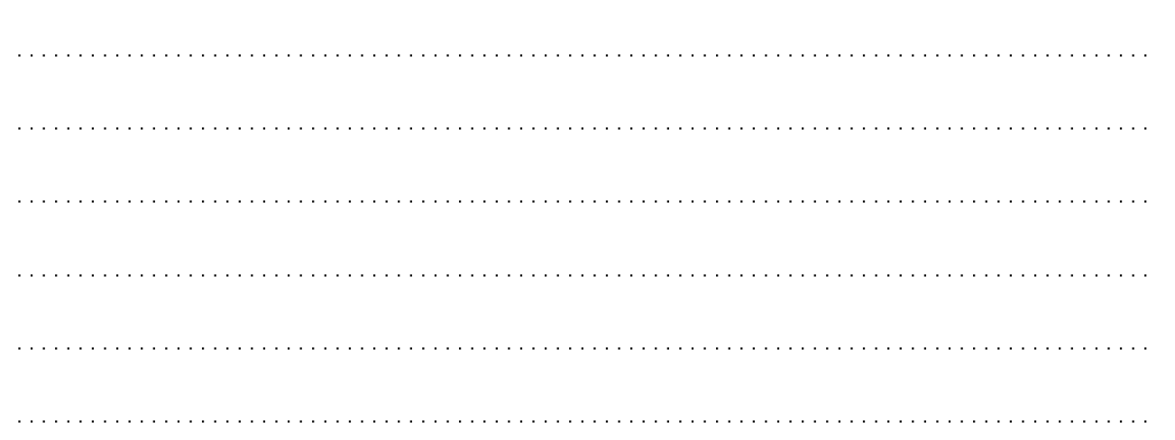

(b) Write down your answer to (a) correct to the nearest integer. [1 mark]
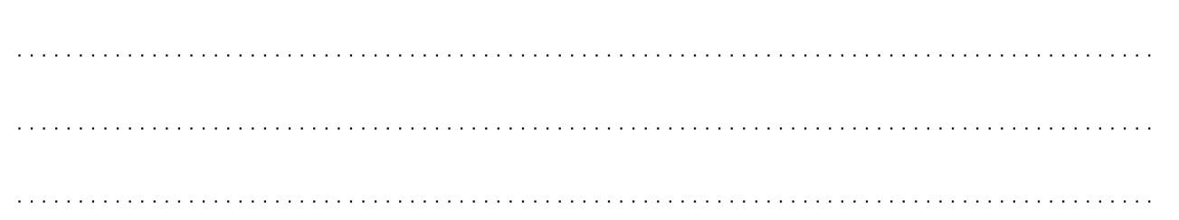

(c) Write down your answer to (b) in the form a × 10n, where 1 ≤ a < 10 and n .
[2 marks]

Question 2. [total marks: 6]
The grouped frequency table summarises the examination results of a group of students.

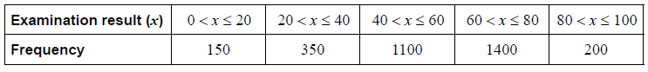

- Write down the modal class.
[1 mark]

- Write down the mid-interval value of the modal class.
[1 mark]

- Calculate an estimate of the mean examination result.
[2 marks]

- Calculate an estimate of the standard deviation, giving your answer correct to three decimal places.
[1 mark]

Question 3. [total marks: 6]
A sequence has general term $u_{n}=3n+1$, for $n≥1$.
(a) Write down the first three terms of the sequence. [1 mark]

(b) [5 marks]
(i) Expand as the sum of four terms.
$$\sum_{n=21}^{24}{(3n+1)}$$

(ii) Calculate.
$$\sum_{n=21}^{100}{(3n+1)}$$

Question 4. [total marks: 8]
Andrew is at point A in a park. A deer is 3 km directly north of Andrew, at point D. Brian is 1.8 km due west of Andrew, at point B.

(a) Draw a diagram to represent this information. [2 marks]

(b) Calculate the distance between Brian and the deer. [2 marks]

(c) Calculate the bearing of the deer from Brian. Give your answer to 1 decimal place.
[4 marks]

Question 5. [total marks: 8]

A sum of $5000 is invested at a compound interest rate of r %, compounded monthly.

- Write an expression in terms of r and n for the value of the investment after n full years.
[2 marks]

After 5 years, the investment has a value of $6100.

(b) Find r. [3 marks]

Inflation over the 5 years averaged at 2% per year.

(c) Find the real value of the investment after 5 years. Give your answer to 2 d.p. [3 marks]

Question 6. [total marks: 3]
From January to September, the mean number of car accidents per month was 630. From October to December, the mean was 810 accidents per month.
What was the mean number of car accidents per month for the whole year?

Question 7. [total marks: 13]
An arithmetic sequence is defined as
$u_{n}=135+7n$ , n = 1, 2, 3, …
- Calculate $u_{1}$ , the first term in the sequence.
[1 mark]

- Write down the common difference.
[1 mark]

Sn is the sum of the first n terms of the arithmetic sequence.
- Find an expression for Sn. Give your answer in the form $S_{n}=An^{2}+Bn$ , where A and B are constants [3 marks]

The sum of the first n terms of the arithmetic sequence is 11 991.
- Find n. [3 marks]

The first term, $v_{1}$, of a geometric sequence is 20 and its fourth term $v_{4}$ is 67.5.
- Show that the common ratio, r, of the geometric sequence is 1.5. [2 marks]

Tn is the sum of the first n terms of the geometric sequence.
- Calculate $T_{7}$ , the sum of the first seven terms of the geometric sequence. [2 marks]

- Use your graphic display calculator to find the smallest value of n for which Tn > Sn.
[2 marks]

